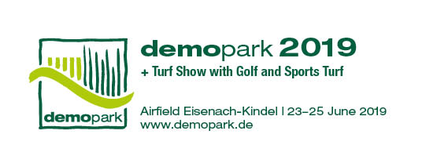

- Press Information -

Christoph Götz
+49(0)69-6603 1891
+49(0)69-6603 2891
presse@demopark.de
02 July 2018
Contact
Phone
Fax
Email
Date

Press information 1

A year in advance of the exhibition: demopark registrations already at a high level
Frankfurt, 02 July 2018 – A year before the start of the exhibition, exhibitors are already lining up. Dr. Bernd Scherer, demopark initiator, is very satisfied. The VDMA Managing Director, who developed the successful open-air format more than two decades ago, is pleased to announce that “the demopark brand is more attractive than ever. Exhibitor demand is already exceptionally high.” In Eisenach, in the German state of Thuringia, more than 400 exhibitors and 33,000 trade visitors are expected from 23 to 25 June 2019.

High tech for tough everyday practical applications

In an area measuring 250,000 square metres, the Innovation Show owes its attraction primarily to the fact that “it targets gardening, landscaping, and turf and golf course professionals not only with marketing, but offers them tangible benefits.” The exhibition in Eisenach focuses on high tech for tough everyday practical applications. In this context, a polished appearance and display become irrelevant. “We take practitioners seriously, showing them how the latest machinery and equipment, mechanics, sensors and hydraulics prove their worth in professional applications,” emphasises Dr. Scherer.

Enormous range of products

With its enormous range of products “to handle and try out”, demopark is clearly differentiated from the spatially limited possibilities of an indoor exhibition. Whether it is autonomous mowing machinery, powerful tractor concepts or ultra-quiet battery-powered chainsaws – those searching for innovative technological ideas find what they need at demopark.

However, the exhibition is also of value to turf experts: With attractive field demonstrations and exciting expert presentations, the Turf Show, organised under the auspices of the German Turfgrass Society (DRG – Deutsche Rasengesellschaft e.V.) and in cooperation with the German Greenkeepers’ Association (GVD – Greenkeeper Verband Deutschland e.V.), informs interested visitors about topics concerning sports and golf turf.

Largest industry exhibition in Europe

Since 1999, Europe’s largest open-air exhibition for the green sector has been held once every two years by the Gesellschaft zur Förderung des Maschinenbaus mbH, a wholly-owned subsidiary of VDMA. More information can be found at www.demopark.de/en.

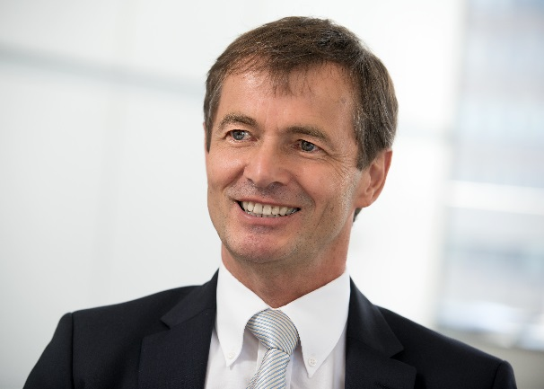

Dr. Bernd Scherer,
Managing Director of the VDMA Agricultural Machinery Association
Source: VDMA.

