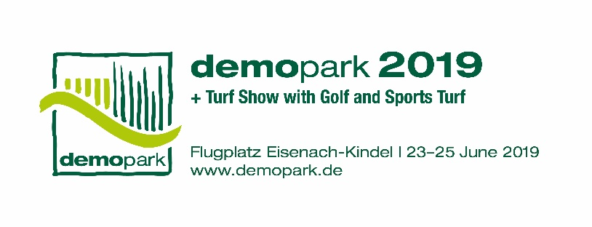

- Press information -

Christoph Götz
+49(0)69-6603 1891
+49(0)69-6603 2891
presse@demopark.de
21 February 2019

Contact
Phone
Fax
Email
Date

Press information 2

Tractors at demopark 2019 in Eisenach
Compact power for landscaping and municipalities

Frankfurt, 21 February 2019 – From 23 to 25 June 2019, demopark 2019 will open its gates in Eisenach. At Europe’s largest open-air exhibition for landscape care and municipal services, well-known brands will display their innovations – among them manufacturers of municipal and compact tractors. Interested visitors can examine and even test the models at first hand, on the 25-hectare exhibition grounds.

“Small tractors are multifunctional. They serve as implement carriers, with three mounting points at the front, middle and rear, and undertake very diverse tasks,” explains Exhibition Director Dr. Bernd Scherer. Anyone interested in a municipal tractor today can find an extremely multi-faceted range of offerings on the market.

Small diesel variants starting at 20 hp

Even small lawn tractors can be included among municipal tractors. Although models with petrol engines which are not approved for road use are primarily designed for private customers, as a rule somewhat larger models with diesel engines and approximately 20 hp are definitely suitable for municipalities and service providers. The basic features of these models, originally built for lawn care, include mid-mount mowers and rear discharge systems with grass collection. Some models can also be enhanced with cabs, front power lifts, and front power take-offs. However, these models usually have no power lift or power take-off at the rear.

In the subcompact tractor segment ranging from 25 to 35 hp, rear three-point hydraulics and rear power take-offs can also be found. Here customer groups extend from private customers, to the service provider sector, to municipalities.

Three groups in the compact class

Compact tractors are classified by most manufacturers into three groups, according to their performance:

- Group I, compact tractors from approximately 15 to 30 hp: In some cases, even these small tractors have power steering, mid-mount power take-offs and two-tier rear power take-offs. Some of them can lift over 600 kg with the rear power lift. Even in this class there are models with a front power lift and front loader.
- Group II, compact tractors from approximately 30 to 45 hp: In this class manual or hydrostatic transmissions are available. With some hydrostatic systems, the driver can change between forward and reverse with the aid of a dual pedal. Other common features include rear power lifts with a lifting capacity of over 900 kg, front loaders with a lifting capacity of around 500 kg, and transport speeds of up to 25 km/h.
- Group III, compact tractors from approximately 45 to 60 hp: These can lift over 700 kg at the rear, or up to 1000 kg with the front loader, and can be equipped with all-wheel drive.

Engine performance not the only deciding factor

“However, in choosing the right tractor, the deciding factor is not always engine performance; often it is the external dimensions or the weight distribution. Today there are solutions on the market to meet every requirement,” states Dr. Scherer. For example, high performance offers no advantage if the machine is too wide to travel on the footpath, or to pass through a garden gate or between the rows in a vineyard. In contrast, for work on slopes, for instance on a dyke or embankment or in a low mountain range, wide vehicles with a low centre of gravity are needed. For frequent work under trees or other areas of application there are machines with low-height construction.

Tractors with a tight turning radius are advantageous, particularly for loading work. For difficult ground conditions, manufacturers also provide all-wheel drive as a standard feature. In addition, there are models with different numbers of hydraulic control circuits – which are suitable depending on how many mounted implements are to be operated simultaneously.
In some vehicles the driver can adjust the transmission response to the specific application: More aggressive for front loader work, or gentler for lawn care. Manufacturers now combine the advantages of a convenient hydrostatic system with the clearly defined speeds of a manual transmission.
Here shifting into reverse, forward, and up to twelve speed levels can be performed without a clutch. This possibility is considered to be attractive especially for work on golf courses and lawn care.

Ever more equipment for small machinery

“In addition to tractors themselves, an extensive programme of accessories and mounted equipment is also crucial for handling the work. Here, too, solutions can be found in Eisenach,” says Dr. Scherer. Because quick changes of equipment are important for practitioners, many tractor manufacturers offer quick-change systems. Equipment such as mowers should be mountable and dismountable with short setup times, if possible without the use of tools. Increasing numbers of manufacturers are focusing on smaller and lighter carrier vehicles. For instance, sweeper manufacturers are offering machine variants with and without dirt collection that have working widths of 120 to 150 cm.

Mowing to protect beneficial species

The spectrum of mounted equipment is also affected by new requirements: Increasingly, nature conservationists demand mowing that protects beneficial species in green spaces, wasteland, and nature conservation areas. Here double-blade mowers are needed, since rotary drum and disc mowers can harm beneficial species. Formerly, the costly sharpening of the blades was seen as a disadvantage of double-blade mowers. However, thanks to solutions for automatic sharpening, this older technology is once again becoming a focus of attention.

Experience technology at first hand

In many cases, these tractors with their special functions and features can also be tested in practice by visitors to demopark 2019. All well-known manufacturers of small, compact, and municipal tractors and other versatile carrier vehicles are represented at the exhibition. At the Eisenach-Kindel airfield, measuring approximately 25 hectares, there is ample space to operate machines and their mounted equipment. The exhibition is held by the Gesellschaft zur Förderung des Maschinenbaues mbH, a wholly-owned subsidiary of VDMA. Additional information can be found at: www.demopark.de/en

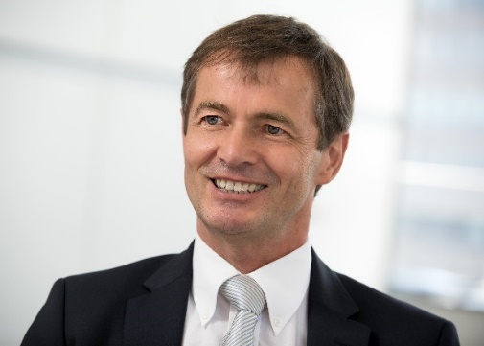
Dr. Bernd Scherer, Exhibition Director and VDMA Managing Director. Source: VDMA.

