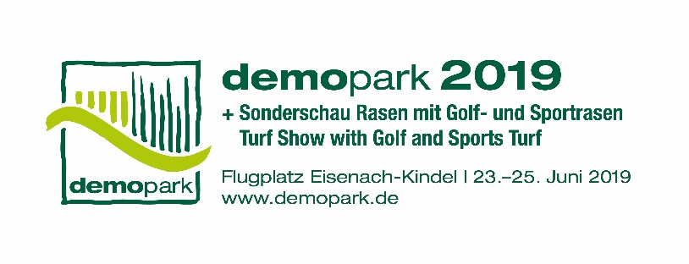

- Press information -

Christoph Götz
+49(0)69-6603 1891
+49(0)69-6603 2891
presse@demopark.de
08.03.2019

Contact
Phone
Fax
Email
Date

Press information 3

“Municipal machinery goes electric”
Electrical machinery and equipment at demopark 2019

Frankfurt, 8 March 2019 – More and more municipalities and service providers are choosing electric drives for machinery and equipment as quiet, inexpensive and low emission alternatives to combustion engines. The latest models of all renowned manufacturers will be on display from 23 to 25 June at demopark 2019 – Europe’s largest open-air exhibition for public area maintenance and other municipal services. Interested visitors can inspect the models at first hand and test them on the 25-hectare grounds.

More and more scenarios for use

“Electricity is becoming increasingly popular as a drive – also in municipalities. As large-scale production develops, batteries are becoming smaller, more powerful and less expensive”, says exhibition director Dr. Bernd Scherer. He adds that “according to the existing learning curve, prices drop by six to nine percent with each doubling of the worldwide production volume.” Hence there are also an increasing number of scenarios for the use of electric drives in agricultural and municipal machinery. Reasons in favour of this development are:

- Many farmers or municipalities produce solar electricity on the roofs of their buildings. They are keen to use the electricity from newer systems as far as possible for their own operations as they can only feed it into the grid at a tariff of €0.12/kWh or less, while having to buy electricity at a price of over €0.20/kWh. However, there is not always sufficient machinery and equipment available that can be operated on the farms during the day, particularly during strong solar radiation. It would be practical if electric vehicles could be flexibly charged during these periods, thus increasing the proportion of self-consumption.

- The phenomenon will increase rapidly when, after a 20-year term, the first solar power systems no longer receive compensation in accordance with the German Renewable Energy Sources Act (EEG –Erneuerbare-Energien-Gesetz) as from 2020.

Exciting ideas for electric vehicles

Manufacturers are offering more and more models for municipalities and service providers. They run on either lead-based or lithium-ion-based accumulator batteries, which provide electricity for both the traction drive and the working hydraulics. Run time is between several hours and one working day. The machinery can be connected to the socket via on-board battery chargers for recharging.

What must be mentioned here besides compact tractors are, for example, electric wheel loaders, commercial transport vehicles with flat beds or box bodies, refuse collection vehicles and sweepers. In addition, the range of hand-guided professional devices with storage battery drive is growing steadily. Saws, scythes, hedge trimmers or cut-off grinders have long been accepted in the industry. Construction machinery such as vibratory plates round off the range. Electric drives are becoming increasingly important in the building industry – particularly as the devices can be easily rented for specific projects, for example for interior renovations or tunnel construction. Building firms and municipalities alike are bound by strict guidelines of the employer’s liability insurance associations regarding emission limit values. Gardening and landscaping companies are generally open to battery-driven products as they work largely in urban areas, parks and private gardens and therefore prefer quiet electric drives.

Fuel costs are dropping

Efficiency levels of 90 percent and more ensure that electric drives are an economical solution. Combustion engines, on the other hand, convert roughly 60 percent of the energy used, mainly into heat. Low maintenance costs and running costs are further advantages of electric drives. Operators of agricultural and construction machinery report that fuel costs can be more or less halved with an electric drive in comparison to a combustion engine.

However, electrification is not merely a matter of replacing the diesel tank with rechargeable batteries. In the course of the years, electric motors have become considerably smaller and the energy density of the lithium-ion batteries has increased significantly. This makes it possible to use the batteries on tractors or other machinery. However, one kW of driving power realised by batteries currently requires more space than would be necessary for diesel fuel or hydraulic components. Manufacturers therefore need to utilise installation space skilfully.

Driving ranges and system costs are further limiting factors for batteries. A tractor with a power output of 50 kW and operating times of of four hours a day requires a battery with an energy content of 100 kWh. This battery would weigh roughly 600 kg and have a volume of 300 l.
However, a 500 hp (380 kW) tractor would have a volume of 5 m³ and weigh 15 tonnes. That is why manufacturers are primarily starting out with smaller machinery such as compact tractors. The batteries can be charged at a wall socket but that would take a very long time.

New charging systems

Charging via a three-phase connection (400 V, 22 kW charging capacity) is quicker: the battery of an electric machine with 50 kW is fully recharged in five hours. Quick charging with direct current (DC) is possible in less than one hour. However, manufacturers assume that there will be considerable developments in charging technology in the next two to four years – simply because of the developments in the automotive sector. But batteries can also serve to drive ancillary components such as air-conditioning or brake compressors.

Higher precision for mounted equipment

Electric drives are particularly worthwhile for mounted equipment as they enable exact regulation and control. For instance, the speed can be reduced more quickly if disturbances occur, thus preventing expensive damage to the machinery, e.g. if it encounters an obstacle.

Experiencing technology at first hand

Visitors to demopark 2019 can also often test new electric machinery with different battery and charging systems under practical conditions. The renowned manufacturers of equipment in the various classes – from electric compact tractors to battery-operated hedge trimmers – are all represented at the exhibition. The 25-hectare airfield in Eisenach-Kindel provides ample space for on-hands testing of machinery and mounted equipment. The exhibition is held by the Gesellschaft zur Förderung des Maschinenbaues mbH, a wholly-owned subsidiary of VDMA. Additional information can be found at: www.demopark.de/en

Dr. Bernd Scherer, Exhibition Director and VDMA Managing Director. Source: VDMA.

