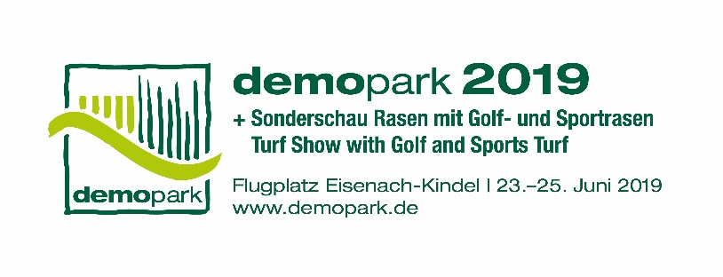

- Press information -

Christoph Götz
+49(0)69-6603 1891
+49(0)69-6603 2891
presse@demopark.de
23.04.2019

Contact
Phone
Fax
Email
Date

Press release 7

demopark putting artificial intelligence on the road
Europe’s largest open-air exhibition, in Eisenach from June 23 to 25

Frankfurt, 23 April 2019 – For fleet management and documentation of summer and winter road maintenance work, municipalities are increasingly relying on digital solutions. For the first time, there is machinery operated in an autonomous driverless mode. From June 23 to 25, visitors can admire what is already technologically possible at demopark 2019 – Europe’s largest open-air exhibition for landscape care and municipal services. On the 25-hectare exhibition grounds, interested visitors can examine and test innovative networking ideas at first hand.

Telemetry for verification management

Workers from construction, road and motorway maintenance depots are underway on the roads on a daily basis. They prune back trees at the edge of the road, mow verges, clear ditches or apply salt and brine to combat ice. If vehicle damage or accidents occur despite these measures, legal verification is important: What work was carried out where, when, and by which driver? How much grit was applied at what time, at which intersection? What was the outdoor temperature at that time, and was there precipitation?

These data, which formerly had to be laboriously collected and submitted by hand, are now handled automatically, practically in real time, by modern telemetry systems. With the aid of GPS, intelligent on-board computers capture the time, the route driven and weather data. The computer also employs machinery data: Information about speed, the quantity of grit applied and other work carried out is transferred by sensors and transmitted via radio to the cloud. The data is not only documented but can also be retrieved at any time by employees at the control centre – for instance, to track the location of machinery or to optimize the machinery operation if required by the current situation.

Fleet networking

Digitisation thus not only offers new functions for individual carrier vehicles or machines, but also permits networking of the fleet. This aids day-to-day operations, as well as providing legal verification in the event of legal disputes and assisting with documentation to evaluate capacity utilisation for increased efficiency.
Despite the utility of the new technology, the buzzwords digitisation, telemetry and artificial intelligence sound very theoretical to many practitioners. At the demopark 2019 exhibition in Eisenach, municipality and service provider employees can experience at first hand precisely what these concepts mean, and where and how the relevant machinery components are installed and operated. Rather than displaying well-polished machinery in exhibition halls, demopark allows the machines to be driven and tested in the open air at the Eisenach-Kindel airfield, on exhibition grounds extending over 250,000 square metres. This enables exhibitor experts to make the benefits of machinery digitisation perceptible.

Diverse fields of application

At the exhibition stands, visitors learn how widely applicable digitisation and telemetry already are:

- As is the case in agricultural machinery, the ISOBUS is increasingly being used as a central unit in municipal vehicles. For instance, via a standard interface it can link the carrier vehicle on-board computer with a salt spreader or snow blower. The advantage: the driver needs only a non-proprietary operating terminal and does not have to adjust to a new device each time.

- As well as providing current operating data such as the speed or quantity of applied material (e.g. grit) to the connected Internet portal or cloud, the machinery sensors also indicate the hours of operation. This means that the road maintenance depot obtains a better overview of how often which machine has what malfunctions, when maintenance is required, and how the preventive replacement of wear parts can be planned. These data also facilitate the analysis and optimisation of the use of salt, grit, brine and other consumable materials.

- Moreover, the data contribute to faster identification of machinery in the event of theft. This can be very useful, for instance, in the case of a fleet of robot mowers.

- The telemetry data captured can not only be viewed by employees at the depot but can also be retrieved by other authorised users anywhere in the world, via a smartphone or tablet.

- In addition to machinery data, documentation can also include photographs of maps showing the route, or updated images of the situation on site (e.g. road conditions, or a photograph of the edge of the road after the work has been completed). There are initial solutions where modified smartphones mounted on the front windshield of garbage collection vehicles or sweepers take photographs every minute. The transmitted images can be analysed via software, thus permitting road damage such as potholes or cracks to be detected automatically.

- In future, the Internet of things will allow equipment and machinery to be linked to one another. This technology, which is already established in many organisations, will also be of interest to municipalities. An example is a brine mixing facility in a construction yard that can be connected to an emergency warning device. If there is a problem, the responsible employee will be immediately alerted.

Sweepers with laser sensors

Development continues unabated: Currently the first autonomous sweepers are already being tested. They are equipped with laser sensors, and – similarly to robot mowers on sports fields and green spaces – are designed to drive independently through the streets. Because many legal issues remain to be clarified, autonomous work machinery is still a dream for the future. However, here too, demopark exhibitors can give an assessment: What is in preparation, and what can municipalities expect in the coming years?

At demopark 2019, visitors will find all well-known manufacturers of municipal machinery in the various equipment classes – from handheld power tools to heavy trucks for highway use. At the Eisenach-Kindel airfield, measuring around 25 hectares, there is ample space to examine machinery and its mounted equipment in detail. The exhibition is held by the Gesellschaft zur Förderung des Maschinenbaues mbH, a wholly-owned subsidiary of VDMA. Additional information can be found at: www.demopark.de/en

Do you have any questions? Christoph Götz, demopark press spokesman, will be pleased to provide you with additional information (telephone +49(0)69-6603 1891)!

