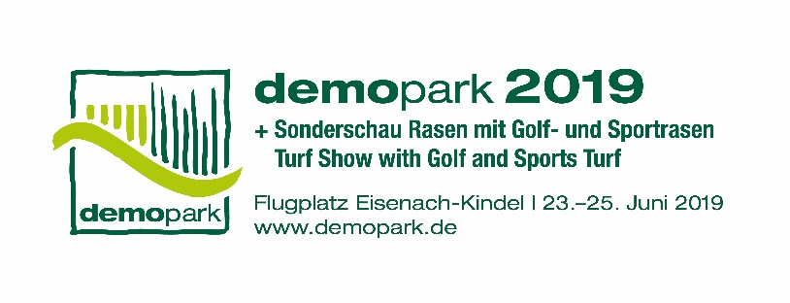

- Press information -

Christoph Götz
+49(0)69-6603 1891
+49(0)69-6603 2891
presse@demopark.de
28.03.2019

Contact
Phone
Fax
Email
Date

Press Release 6 - Press Briefing

‘Off to demopark!’
Europe’s largest open-air exhibition from 23 to 25 June in Eisenach

Frankfurt, 28 March 2019 – The countdown has begun. In less than three months’ time, from 23 to 25 June, it will once again be all about ‘touching, climbing aboard and trying out’ when Europe’s largest open-air exhibition opens its gates for the eleventh time at Eisenach Kindel. “Demopark is different from other trade fairs; demopark is technology through and through”, says VDMA managing director and exhibition director Dr. Bernd Scherer.

Knowing the developments in the sector

This year, more than 80 innovative product ideas have entered the ambitious international Innovation Competition for municipal machinery, green space maintenance and golf course construction. In June, 15 of these products will be awarded one of the coveted demopark innovation medals.

“Off to demopark!”, Scherer enthusiastically calls out to the sector, adding that only those present can “gain a full picture of innovative developments in the green sector”. The technology exhibition, which is organised in conceptual partnership with VDMA, regularly attracts more than 35,000 visitors from the gardening and landscaping industry as well as greenkeepers and municipal experts to the Thuringian town of Eisenach.

Unique demonstration approach creates utility

Demopark is committed to its traditional motto: ‘At the heart of practice and at eye level with the user’. “With our machinery, equipment and systems programme, presented in a unique way, we create actual utility for all visitors. Our consistent demonstration method is certainly more typical of the sector and provides a far better decision-making basis for machinery purchases than the usual static exhibition of highly polished machinery, which often may not even be touched”, Scherer explains.

International attractiveness

A glance at the registration list shows how attractive demopark is throughout the sector. With about 400 exhibitors, the organiser has once again almost reached the capacity limits. This is due to the fact that many exhibitors have expanded their space again, enabling them to present additional interesting machinery to practitioners in attractive surroundings.
But the trade fair organisers also remain on course at the international level: “We are proud to welcome roughly 80 exhibitors from a total of 16 countries to Eisenach at the end of June. This consistently high level also underlines the international attractiveness of this innovation exhibition”, says Scherer.

Economic situation in the sector gives cause for optimism

Economic developments play into the sector’s hands too,
as sales of German products show. Domestic manufacturers of machinery and equipment for green, grey and white grounds maintenance achieved a substantial increase of 4 percent in sales in the past three years, with a production volume of €440 million in 2018. The market volume in Germany is even €750 million, including imports; this is a new all-time high for the sector.

If one divides the total result according to sector segments and areas of use, ‘white maintenance’ (i.e. winter maintenance) with an increase of 6 percent, albeit from a low base, has proved to be a dynamo for growth. ‘Green space maintenance’, the most significant area of use in terms of value, remained stable at a high level; in view of the extremely dry weather last year, this is a good result. ‘Grey maintenance’, ‘i.e. the maintenance of stone, asphalt and gravel surfaces, has levelled off in between these two segments, with a slight increase of 1 percent. “In a positive sense, the ‘real’ winter – at least in the Alpine region – in the season of 2017/2018 and, in a negative sense, the ‘drought of the century’ last summer were the causes of this mixed economic result. The latter was particularly noticeable in the northern and eastern parts of Germany. Here specialists for irrigation systems were the only ones to profit”, says Scherer.

Increase of 6 percent in turnover expected
VDMA expects further growth at German manufacturing sites for the current financial year. Incoming orders, which economists consider to be a significant early indicator, are currently increasing across segments, with growth between 3 and 4 percent. The sector is benefiting noticeably from this dynamic development. “With an export rate already significantly above 50 percent, one thing becomes clear: machinery and equipment manufactured in Germany are in demand all over the world as efficiency drivers to meet the diverse challenges facing municipalities and the gardening and landscaping industry”, Scherer emphasises.
The industry expects considerable growth of 6 percent in the German production volume in 2019, which will then reach a good €466 million. Naturally, a growth path like this one varies in intensity in the individual sales markets. Last year, business was good in France, the sector’s largest export market. Almost every fourth machine produced for export is for Germany’s western neighbour. Sales to the Netherlands are similarly positive, accounting for 15 percent of Germany's exports. But the gardening and landscaping and the municipal machinery industries are already achieving noteworthy successes in Poland and the Czech Republic too. “In the long term, both countries are likely to catch up with the top growth markets. Asia is stepping up as well, also and particularly as an export market. There is obviously increasing demand in these regions, too, for innovative professional technology of a reliable quality”, Scherer points out.

Clearly on digitalisation course

From a technical point of view, the signs are pointing clearly to digitalisation. “We are currently primarily observing a development which is ensuring that automation and digitalisation are increasingly merging to become a functioning unit”, the VDMA managing director says. “Improved efficiency and less downtime, better documentation and less bureaucracy can be expected”, he adds. There is no doubt that autonomous operating concepts, predictive maintenance, interlinked vehicle concepts, digital logistic chains and software-aided documentation processes characterise innovation today. The manufacturers’ research and development departments are certainly working at full speed to achieve this, always under the assumption of an increased economic benefit, which, however, must be combined to a large degree with comfort and user-friendliness. Because long-term success in the markets can only be achieved with an integral understanding of innovation.

Special Shows to encourage thinking outside the box

However, as a stage for the future, demopark is not satisfied with simply focussing on the machinery and equipment when dealing with the topic of innovation. “Our exciting special shows, which are just as well-known as our unique demonstration format, have proved this for many years now. The aim of the special shows is to inspire, surprise and educate, but also to encourage thinking outside the box”, Scherer explains.

With the special Tree Generator show, the organiser wants to raise visitors’ awareness in a playful way for the importance of trees in urban green spaces. Embedded in the ‘C2tree’ initiative, which has been actively promoting sustainable tree planting throughout the country for several years now on the basis of a sponsoring arrangement, the Special Show provides a platform particularly for the complex machinery needed for transplanting large trees.

This year, the Special Turf Show will also be presenting brand new maintenance ideas for turfgrass professionals in the context of innovation. The Greenkeeper’s Turf Day 2019 will be focussing on ‘Programmable Assistance Systems’, the digital topic for the future, among others.

“With the demopark Municipal Day on the Tuesday of the exhibition, we want to continue the success of the past event. The approach of implementing an attractive conference programme for the municipal sector, which can be actively used as an opportunity for further training, is already bearing fruit", Scherer says. Interesting ideas and novelties will be presented and discussed under the motto of ‘Practice-oriented technologies for municipalities’. Ideas for digital interlinking and more conventional approaches will be equally taken into consideration − true to the principle that efficiency is what counts!

The demopark exhibition is held by the Gesellschaft zur Förderung des Maschinenbaues mbH, a wholly-owned subsidiary of VDMA. More information can be found at www.demopark.de/en.

Do you have any questions? Christoph Götz, demopark press spokesman, will be pleased to provide you with additional information (telephone +49(0)69-6603 1891)!

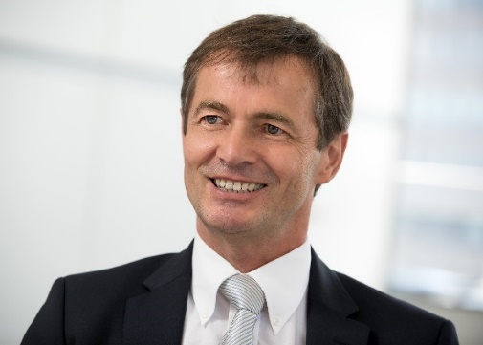
Dr. Bernd Scherer, Exhibition Director and VDMA Managing Director. Source: VDMA.

