DRG Text for a Press Release: Special Turf Show 28 March 2019

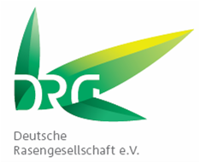 | The green highlight at demopark –  Special Turf Show 2019

With its Turf Show 2019, demopark will once again be presenting exciting topics on the maintenance and quality management of turfgrass areas. The latest research findings and practical solutions will be presented to visitors in the established format of demo lectures on the spot and as poster presentations in the turfgrass competence tent.

Information and demonstrations
Current key topics of research on turfgrass at German universities as well as a selection of Bachelor’s and Master’s theses by young scientists will be presented under the auspices of the German Turfgrass Society (DRG – Deutsche Rasengesellschaft e.V.). In addition, trade visitors will have the opportunity to obtain concise information on further topics such as sustainable turf care, biological pest control and quality management for golf and football turf. Moreover, the poster authors and other members of the DRG will be available for a professional exchange of views on all days.

The practical part is directed at the target groups of the respective Theme Days: here the focus will be on turf renewal for home turf, programmable assistance systems and effective mowing systems as well as the ever-popular topic of turf quality. The professionally moderated presentations ensure a real benefit for the participants.

Species, varieties and mixtures
Ahead of demopark 2019, parts of the lawn surface were removed and replaced with turfgrass sod. Now these areas provide excellent preconditions for the practical demonstrations. This year, the focus of the Turf Show will again be on those varieties of the most important grass species that have been accepted and tested by the German Federal Plant Variety Office (BSA) for use as turfgrass. Visitors can expect a diverse range of rye grasses, meadow grasses and various species of fescue.

Cross sowing demonstrates mixture combinations
The establishment of a “cross sowing” area is a unique feature at the special show. In each case two species of grass, with different varieties, are tested. To this end, the individual varieties of a species are arranged in strips which cross the strips of other varieties. In this way, numerous individual plots with different characteristics are created. This makes quality criteria such as competitive strength, colour characteristics or turf density visible for trade visitors.

RSM regio in a multi-year trial
Pursuant to the German Federal Nature Conservation Act (BNatSchG), the use of regional plants in the open countryside/outdoors is obligatory for all parties involved. The areas, some of which were already sown with ‘regional seed’ at the Turf Show in 2013, display their genetic capacity.

demopark 2019 as recognised further training
On request, interested persons from the municipal sector and greenkeepers of golf courses and sports grounds will receive attendance certificates from the German Turfgrass Society (DRG – Deutsche Rasengesellschaft e.V.) or the German Greenkeepers’ Association (GVD – Greenkeeper Verband Deutschland e.V.) – for instance, for recognition in the GVD training programme.

Anlagen

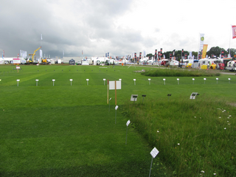
Abb. 1: Die demopark bietet allen Rasenliebhabern etwas: von der Cross-Ansaat über den Gebrauchsrasen bis zum Landschaftsrasen (Foto: Nonn)

