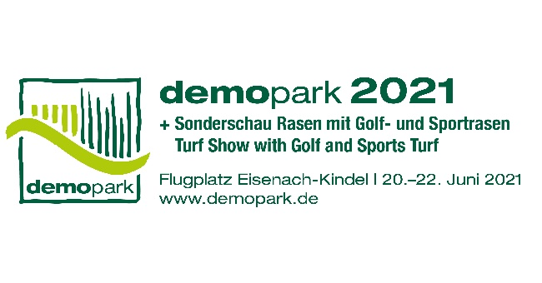

- Press Release -

Contact
Phone
Fax
E-Mail
Date
Christoph Götz
+49(0)69-6603 1891
+49(0)69-6603 2891
presse@demopark.de
06 July 2020

Press Release 2
Great exhibitor interest: demopark 2021 picks up speed

- More innovations
- More exhibition areas
- More demo areas

Frankfurt, 06 July, 2020 – Anyone travelling to Eisenach between June 20 and 22, 2021 can expect something: Because next year Europe's largest open-air exhibition of the green industry will be particularly attractive. "Especially in times like these, our unique open-air concept offers a safe live experience with high utility value", says demopark's Exhibition Director Dr. Bernd Scherer, who also manages the business of Europe's largest agricultural machinery association VDMA Agricultural Machinery.
But demopark has much more to offer. "In order to make even the longest journey worthwhile, we have once again created plenty of space – for more innovations, more exhibition and more demo areas", adds Scherer.

Exhibitor interest above average

With over 100 registrations, exhibitor interest is already above the average values of previous years, only a few weeks after the start of the registration process. "After a number of important trade fairs which had to be suspended this year, many exhibitors obviously want to take the opportunity to present their portfolio of innovations in Eisenach next year. In addition, demopark succeeds like hardly any other industry exhibition in bringing the range of products and services and cost efficiency to a common denominator", Bernd Scherer explains the positive trend for demopark.
Whereas a few square metres can be quickly booked for practical demonstrations in the open air without breaking the budget, the end of the line has already been reached long before that for conventional hall exhibitions.

Continuing on a growth course

"With 250,000 square metres of exhibition space, most of it in the open air, we have a truly unique selling point. Making previously unused areas available for additional great product presentations and demonstrations is our intention. After all, demopark continues to grow very solidly in the third decade of its existence", summarises the trade fair director.

Register online now

Interested manufacturers and sales organisations can download the registration documents for exhibitors at www.demopark.de.The closing date for registration is 30 October 2020. 37,000 trade visitors from 17 countries came to demopark 2019 to obtain information at the stands and demonstration areas of more than 400 exhibitors from all over Europe.

Do you have any further questions? demopark press spokesman Christoph Götz, Tel. +49 69 6603-1891, is at your disposal for further information!

