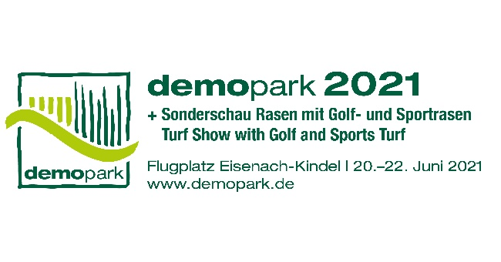

**- Press Release -**

Contact

Phone

Fax

E-Mail

Date

Christoph Götz

+49(0)69-6603 1891

+49(0)69-6603 2891

[presse@demopark.de](mailto:presse@demopark.de)

10 December 2020



**Press Release 3**

**Outdoor exhibition demopark 2021**

**Number of exhibitors skyrockets**

Frankfurt, December 10, 2020 - demopark defies the pandemic. Thanks to the open-air concept and comprehensive hygiene and protection measures, the number of registrations for Europe's largest open-air trade fair for the green industry is skyrocketing. More than 400 exhibitors have already decided to participate next year. It is already certain that there will be plenty to see in Eisenach from 20 to 22 June 2021: Innovative technology, exciting machines, equipment and digital solutions for use in gardening and landscaping, for municipal applications as well as for sports and golf course maintenance are just waiting to be put through their paces in a tough demonstration.

**Touching, getting into and trying out - but safely**

"The fact that we organize an open-air innovation show is a great advantage, especially in times like these. Touching, getting in and trying things out - this unique triad will be brought to life again at demopark next summer", says VDMA Managing Director and demopark Exhibition Director Dr. Bernd Scherer. Regardless of the current difficult situation for trade fairs and exhibitions, Scherer is optimistic: "As we now know, aerosols in the indoor air are a very significant part of the corona hazard. We do not have this problem in Eisenach, true to the motto: 'Open Air - Safe Fair'. Because the extensive airfield grounds, which cover a good 25 hectares, offer the best conditions for an airy stand design in compliance with all conceivable hygiene and safety standards. Our visitors can expect an absolutely safe live experience," explains Scherer.

**Push effect expected on visitor side**

Another argument in favor of demopark is the fact that the costs are kept within narrow limits in contrast to a hall exhibition. On the visitor side, the VDMA even expects a certain push effect.

"After all, in June, after a long vacancy, we will be one of the first live events to offer green professionals, municipal decision-makers and greenkeepers innovative technology to touch and try out," says Scherer.

**Electromobility and networking in vogue**

As the largest technology drivers in the industry, the association calls the future fields of sustainability, intelligence and automation, not only with regard to the individual machine, but increasingly with regard to the entire process. It has long been talking about 'Smart Gardening' and 'Smart City'. Precision and networking are two sides of the same coin: "Think, for example, of GPS-controlled nozzle switching of innovative winter maintenance spreaders, of serial interfaces so that telemetry and spreading data can be fed into all common systems. Networking in the sense of the fleet principle is also playing an increasingly important role in mowing robotics, which has long since made the leap into professional use and can be found in many places, for example in sports field maintenance," says Scherer.

For optimum machine control, multifunctional touch displays are also becoming more and more common, which facilitate data processing and

-transfer is almost child's play thanks to intuitive user interfaces. "The enormous progress made in the field of electromobility should also not go unmentioned: From intelligent route guidance with intermediate charging at defined stopping and discharging points to the exact dimensioning of the battery depending on the required daily range, the range of innovative process solutions can be covered here. However, all this is only a small part of the large range of new products that we will experience at demopark in Eisenach in June," emphasizes Scherer.

**Attractive technical program in preparation**

An attractive specialist program is also a fixed component of demopark. The municipal day is primarily aimed at decision makers from the procurement sector. "In practice-oriented impulse lectures, renowned experts give thought-provoking impulses for exciting technology and management topics of tomorrow: Do customized digital solutions pay off for the municipality? How must a powerful vehicle fleet be set up in the future - purely battery-electric or in terms of an intelligent combination of drive systems? And: What can assistance systems do to attract employees to the new, smart processes? These and many other exciting questions are currently in our specifications for demopark's 2021 technical program," summarizes the trade fair director.

In addition, there are interesting topics about lawn and golf green, as always in cooperation with the German Lawn Society and the Greenkeeper Association Germany. The demopark Theme Scouts are currently compiling the highlights. The trend topics 'city green' and 'drought-resistant plants' are in the running.

**Register online**

Interested manufacturers and sales organizations can download the registration documents for exhibitors at www.demopark.de, but must expect to be placed on a waiting list first.

Do you have any further questions? demopark press spokesman Christoph Götz, Tel. +49 69 6603-1891, is at your disposal for further information!

Follow demopark on Facebook, LinkedIn und XING: @demopark.eisenach