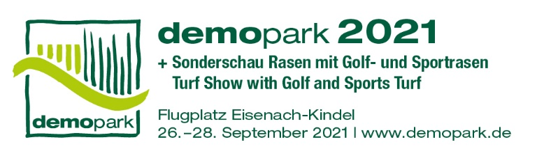

**- Press Release -**

Contact

Phone

Fax

E-Mail

Date

Christoph Götz

+49(0)69-6603 1891

+49(0)69-6603 2891

[presse@demopark.de](mailto:presse@demopark.de)

05 March 2021



**Press Release 4**

**From 26 to 28 September in Eisenach**

**demopark goes for fall date in 2021**

Frankfurt, March 5, 2021 - Europe's largest open-air exhibition for the green industry will kick off in early fall for the first time this year: "demopark 2021 will take place from September 26 to 28 at the Eisenach-Kindel airfield site," says VDMA Managing Director and Exhibition Director Dr. Bernd Scherer. This makes "an exhibition without any significant pandemic-related restrictions" much more likely than at the originally scheduled event date in June.

**Experience innovative technology in a practical way**

"We all love demopark because it turns innovative technology into a real hands-on experience. I am firmly convinced that we will succeed in doing so again this special year. After all, the industry has a host of exciting analog and digital innovations in the pipeline just waiting to be presented in Eisenach," explains Scherer.

**Open Air – Safe Fair**

A sophisticated hygiene and safety concept worked out with the local authorities allows a worry-free visit to the fair for everyone, he adds. "As an open-air event, we have a system advantage over conventional indoor exhibitions in times like these anyway. But we want to offer more than just security, we want a real live experience that is fun and beneficial. This is what our 'Open Air - Safe Fair' concept stands for," emphasizes the association's managing director.

**September date has many advantages**

From the VDMA's point of view, the September date offers tangible advantages, not only in view of the expected more favorable pandemic situation: "We are pleased to now be able to realize a date that does not clash with school vacations anywhere in the country. For gardeners and landscapers, for municipal and golf course professionals, early fall is also the traditional time for investment and purchasing decisions," says Scherer. Last but not least, he adds, the end of September is the time of year to hope for mild weather that is extremely conducive to outdoor events.

On around 250,000 square meters of exhibition space, demopark offers a unique spectrum of innovative technology, exciting machines, equipment and digital solutions for use in gardening and landscaping, for municipal applications and for sports and golf course maintenance. For more information, visit www.demopark.de

**Do you have any questions? demopark press spokesman Christoph Götz,**

**Tel. +49 69 6603-1891, will be happy to provide you with further information!**