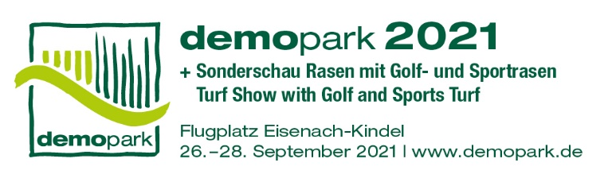

**- Press Release -**

Contact

Phone

Fax

E-Mail

Date

Christoph Götz

+49(0)69-6603 1891

+49(0)69-6603 2891

[presse@demopark.de](mailto:presse@demopark.de)

12 April 2021



**Press Release 5**

**No alternative due to pandemic**

**demopark back in June 2023**

Frankfurt, April 12th, 2021 – Europe's largest outdoor exhibition of the green industry is taking a forced break this year due to the pandemic. "In view of the uncertain situation, we have decided with a heavy heart not to hold demopark 2021," says Dr. Bernd Scherer, demopark trade show director and managing director of the VDMA Agricultural Machinery Association. The decision, which was taken unanimously by the trade fair advisory board, was "currently without alternative, as the protection of visitors and exhibitors is our highest goal."

**Third wave crosses plans**

A few weeks ago, the organizer of the open-air event still had the quite justified hope of being able to circumnavigate the Corona problem to a large extent with an alternative date in early autumn. "However, the third wave of the pandemic, which has been preoccupying us for a few days now, makes a major event like demopark simply unplannable at the moment. If you look at the development of the incidence values, you can unfortunately not come to a more favorable conclusion," explains Scherer.

**Everyone is driving on sight**

The recent disappointing development of the vaccination campaign has made even optimists cautious: "The entire society is driving on sight in the medium term – a personal trade show discussion or even an informal trying out of the innovations is out of the question in such a situation," says the experienced trade show professional.

The industry shares this assessment across the board. Numerous well-known brands had already made the fundamental decision not to attend a trade show in the current year for the reasons mentioned.

**To be continued in early summer 2023**

Bernd Scherer is therefore already looking forward to the early summer of 2023, or to be more precise, June 18 to 20. By then, the special demopark trade fair experience should finally be tangible again. "Our team will ensure that we get to experience an exciting restart, but above all a lively innovation show as we know and appreciate it," Scherer sums up.

On around 250,000 square meters of exhibition space, demopark offers a unique spectrum of innovative technology, exciting machines, equipment and digital solutions for use in gardening and landscaping, for municipal applications and for sports and golf course maintenance. For more information, visit www.demopark.de

**Do you have any questions? demopark press spokesman Christoph Götz, Tel. +49 69 6603-1891, will be happy to provide you with further information!**