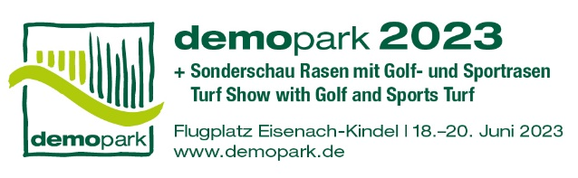

- Press information -

Contact
Phone
Fax
E-Mail
Date
Christoph Götz
+49(0)69-6603 1891
+49(0)69-6603 2891
presse@demopark.de
July 27th, 2022

Press information 1
demopark innovation fair – secure stand space for 2023 now!

Frankfurt, July 27, 2022 - It's on again, live and on site. Preparations are already in full swing for the demopark innovation fair, which will take place from June 18 to 20, 2023 at the Eisenach-Kindel airfield. For manufacturers of machinery and equipment for gardening and landscaping as well as for lawn and golf course care, the following therefore applies: secure your stand space for 2023 now!

Largest outdoor exhibition of its kind in Europe

"Testing innovation in practice and experiencing it up close – that is and remains the brand essence of demopark, which can only be enjoyed in presence and in dialogue with people. Our trade fair professionals are working on it every day to ensure that we will be outstandingly successful in this coming year," says Dr. Tobias Ehrhard, demopark trade fair director and managing director of the VDMA Ag Machinery Association.

The spacious exhibition area of Europe's largest open-air exhibition for the green industry covers more than 250,000 square meters. There, visitors can expect a unique range of machines, equipment and software systems, combined with a top-class technical program in the fields of municipal technology, lawn and golf course care.

Technology with a fun factor

"The longest journey is worthwhile, because nowhere else is the selection so varied, the proximity to the user so great, the fun factor so pronounced," explains Ehrhard. Practice-oriented demonstration areas, combined with plenty of technical illustrative material and highly qualified advice, are the unique selling point of the exhibition.
The coveted demopark innovation medals act as an important indicator of progress, as numerous manufacturers align their innovation cycles with demopark to increase their chances of winning a gold or silver medal.

Registration now possible online

Interested manufacturers and sales organizations can download exhibitor registration forms at www.demopark.de. The deadline for registration is October 31, 2022. At the last demopark, a good 37,000 trade visitors from 17 countries gathered information at the exhibition stands and demo areas of more than 400 exhibitors from all over Europe.

Do you have any further questions? demopark press officer Christoph Götz, Tel. +49 69 6603-1891, is at your disposal for further information!

Dr. Tobias Ehrhard, Exhibition Director
of demopark. Source: Kastner.

